[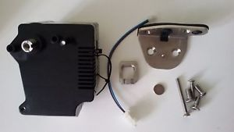](http://www.google.ch/url?sa=i&rct=j&q=&esrc=s&source=images&cd=&ved=0ahUKEwiNh7i_3-DVAhUG1BoKHQfeBp0QjRwIBw&url=http://www.ebay.de/itm/Poessl-Zuziehhilfe-Softlock-Schiebetuer-Ducato-Jumper-Boxer-X250-X290-Kastenwagen-/152008087453&psig=AFQjCNGhT3OJ6kWXQknfWHeLwv5squ8QzQ&ust=1503144414850761)

[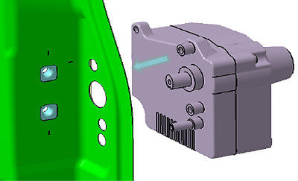](http://www.google.ch/url?sa=i&rct=j&q=&esrc=s&source=images&cd=&cad=rja&uact=8&ved=0ahUKEwjrlOLo3-DVAhXC0hoKHbyRCK8QjRwIBw&url=http://www.ebay.de/itm/Possl-Zuziehhilfe-Softlock-Schiebetur-Ducato-Jumper-Boxer-X250-X290-Kastenwagen/111848859871&psig=AFQjCNGhT3OJ6kWXQknfWHeLwv5squ8QzQ&ust=1503144414850761)

[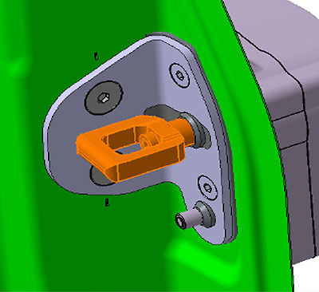](http://www.google.ch/url?sa=i&rct=j&q=&esrc=s&source=images&cd=&cad=rja&uact=8&ved=0ahUKEwjrlOLo3-DVAhXC0hoKHbyRCK8QjRwIBw&url=http://www.m.ebay.de/itm/Poessl-Zuziehhilfe-Softlock-Schiebetuer-Ducato-Jumper-Boxer-X250-X290-Kastenwagen-/111889140528?nav%3DSEARCH&psig=AFQjCNGhT3OJ6kWXQknfWHeLwv5squ8QzQ&ust=1503144414850761)

[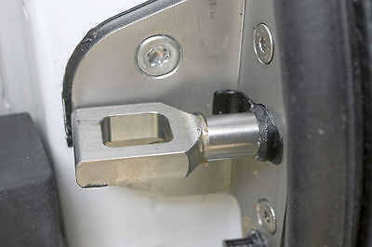](http://www.google.ch/url?sa=i&rct=j&q=&esrc=s&source=images&cd=&cad=rja&uact=8&ved=0ahUKEwicvsTb4ODVAhXLuBQKHRtgCYwQjRwIBw&url=http://www.ebay.de/itm/Possl-Zuziehhilfe-Softlock-Schiebetur-Ducato-Jumper-Boxer-X250-X290-Kastenwagen/111848859871&psig=AFQjCNHMdgvpN6a78Ia0m4pxzhjppVMm7Q&ust=1503144660869212)

[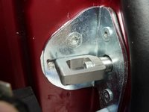](http://www.google.ch/url?sa=i&rct=j&q=&esrc=s&source=images&cd=&cad=rja&uact=8&ved=0ahUKEwifyKXl4ODVAhVPrRQKHYHICYAQjRwIBw&url=http://www.kastenwagenforum.de/forum/threads/fiat-zuziehhilfe.27170/&psig=AFQjCNHMdgvpN6a78Ia0m4pxzhjppVMm7Q&ust=1503144660869212) [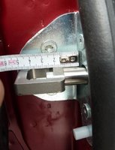](http://www.google.ch/url?sa=i&rct=j&q=&esrc=s&source=images&cd=&cad=rja&uact=8&ved=0ahUKEwjThq344ODVAhUCXBQKHWRTA8gQjRwIBw&url=http://www.kastenwagenforum.de/forum/threads/fiat-zuziehhilfe.27170/&psig=AFQjCNHMdgvpN6a78Ia0m4pxzhjppVMm7Q&ust=1503144660869212)